10. Memory Managment (virtual memory)

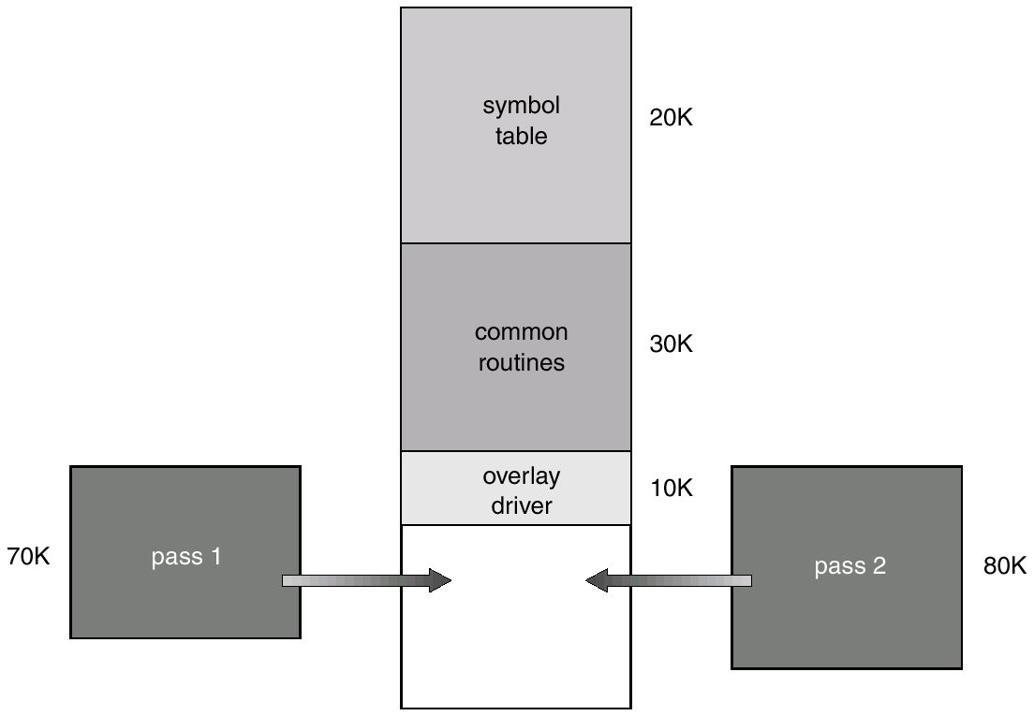
* Single user, single program * Multi-user, single program
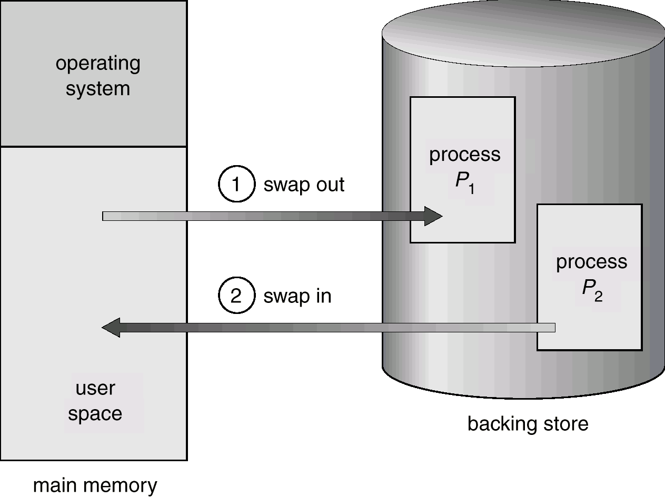

* Virtual Memory larger then physical
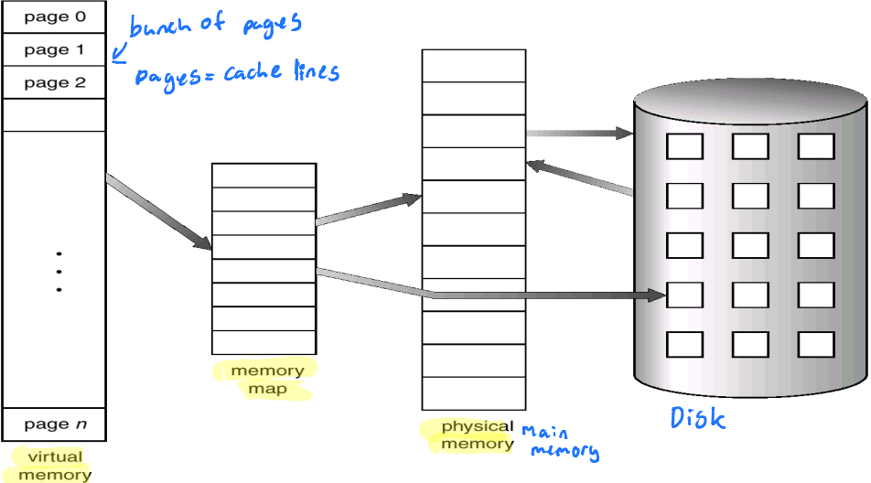

*Virtual Memory Paging (Linear Page Table)
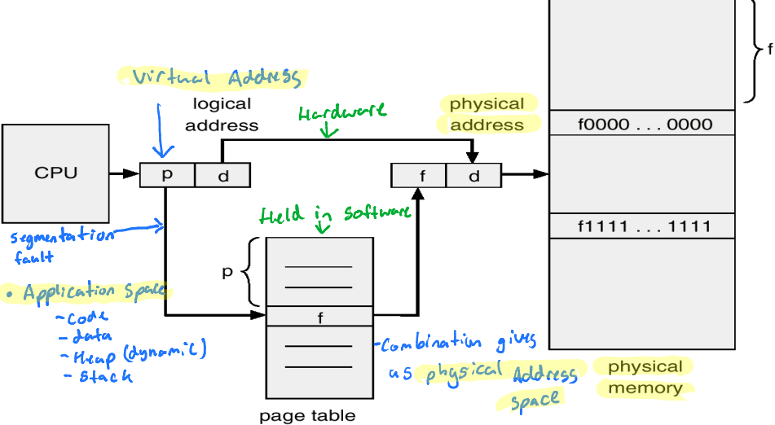
Direct Mapping
MMU = Memory Managment Unit
PTE = Page Table Entry Contents
- usually 32 bits

*Hierarchical page table
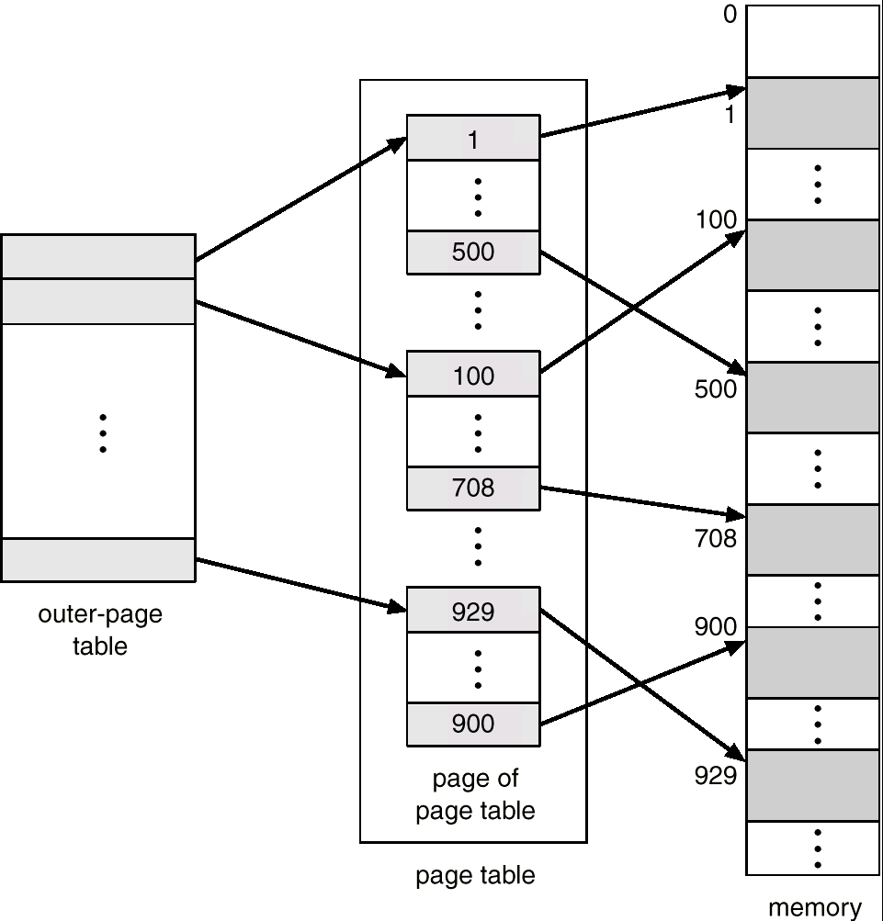

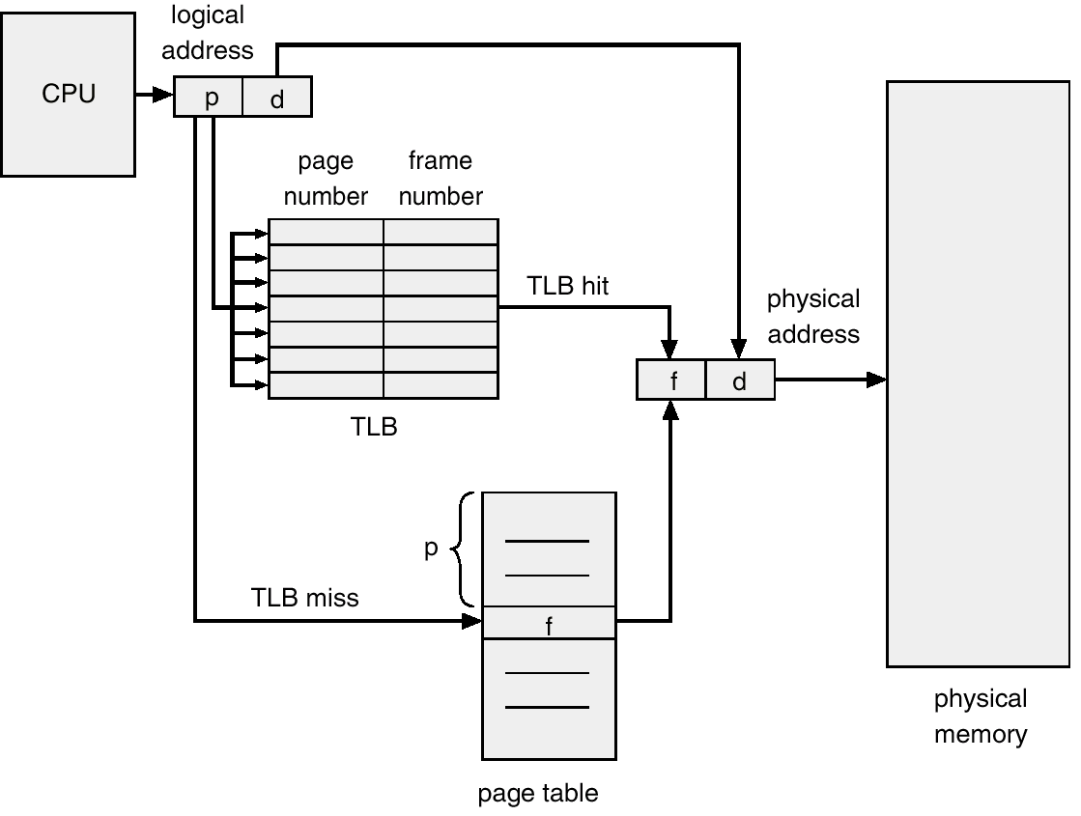
Paging with TLB
def:
- Form of memory cache that is used to reduce the time taken to access a user memory location.
TLB = Translation Lookaside Buffer
- Cache of translations, stored in CPU/MMU
- Small, fully associative (parallel search)
- Expensive
- On the Die

Inverted Page Table (hash table)
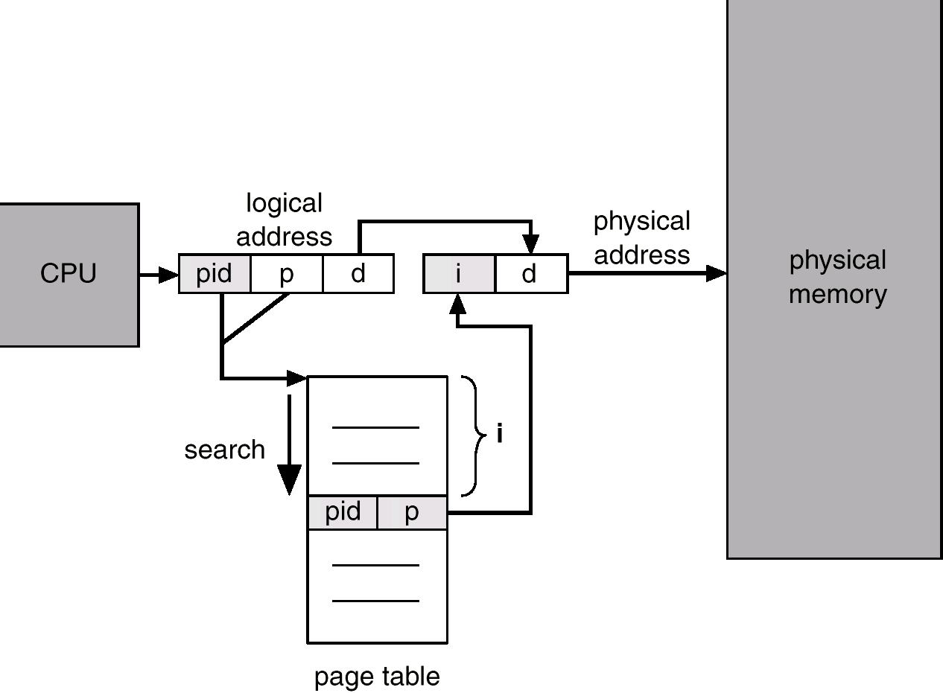
(pid=process ID, p=virtual page number, i=physical frame address, d=offset)
- Faster then normal TLB

Address space divison
-Some memory should not be cached (e.g.device registers) (volitile memory)

Segmentation

